Normalization Process Add Hanzi to Pinyin Transliterations | 

Yoel Kortick
Senior Librarian

Add Hanzi to Pinyin Transliterations

This process Converts Chinese content (Hanzi) to Pinyin.
This can be seen via the CNMARC profile.

- Go to Resource management configuration menu > Cataloging > Metadata Configuration > CNMARC
- Switch to “Normalization Processes” tab
- Either add a new normalization process or view existing one
- In the “Task List” tab see “Add Hanzi to Pinyin Transliterations”
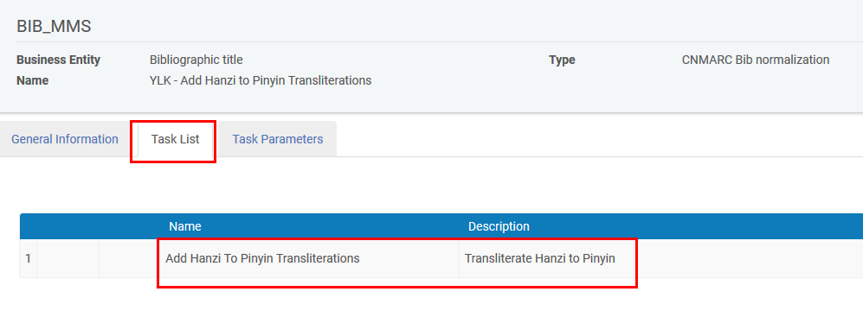
- In the “Task Parameters” tab add the desired fields and subfields from the source fields as well as the desired fields and subfields of the target fields
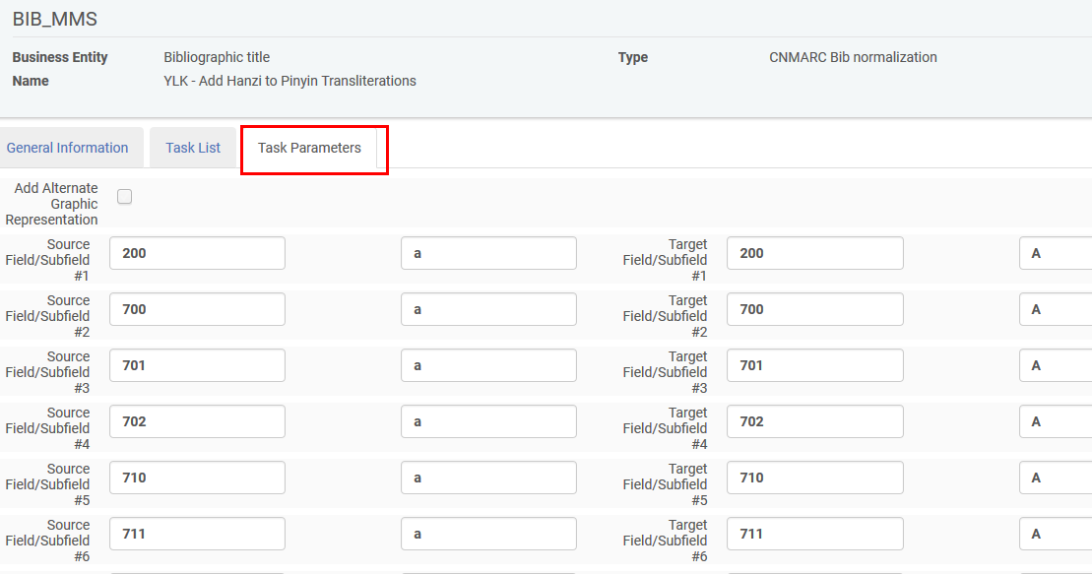
- See it work as follows:
  - Open a record which has the source fields above (so there will be something to translate to Pinyan)
  - Choose Edit record > Enhance Record > Add Hanzi to Pinyin Transliterations
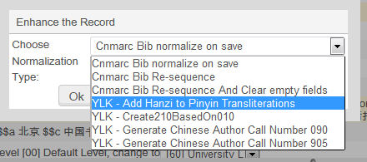
  - See the new subfield A occurrences
Before
After

